 | Price list  Socrate 4 Internet |  | Price in   Ex VAT  (+21%)
 | Usage licence for a new installation
 | Socrate up to 20.000 books |  | 1.067,00
 | For 1 server & 1 catalogue *
 | Socrate up to 40.000 books |  | 1.348,00
 | For 1 server & 1 catalogue *
 | Socrate up to 60.000 books |  | 1.964,00
 | For 1 server & 2 catalogues *
 | Socrate more than 60.000 books |  | 2.525,00
 | For 1 server & 3 catalogues *
 | Annual support & usage contract
 | 15 % of the licence price. |  | *Mandatory
 | Upgrade prices from Socranet
 | -15 % discount on the price for a new installation!
For more price details - Socrate 4 Windows, customizable list editor, support and usage contract, etc..-.

Please see our website

www.socrate.be

S4I in images...

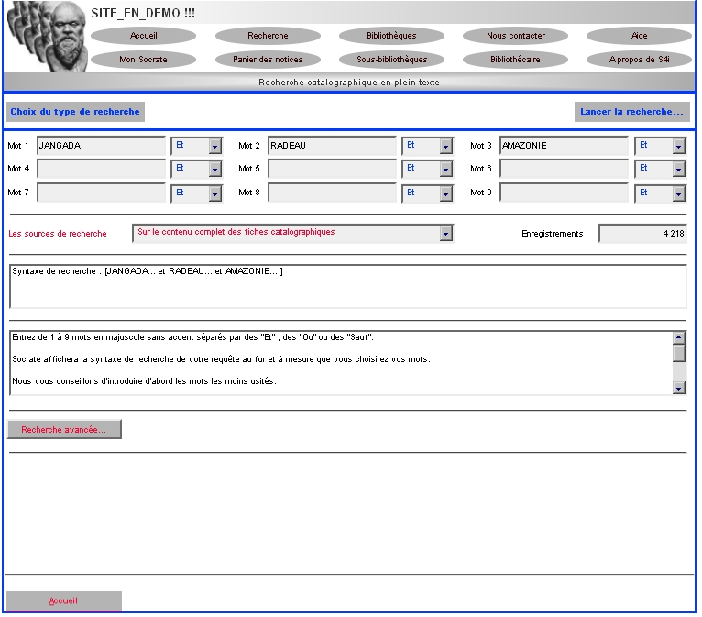

Full text search

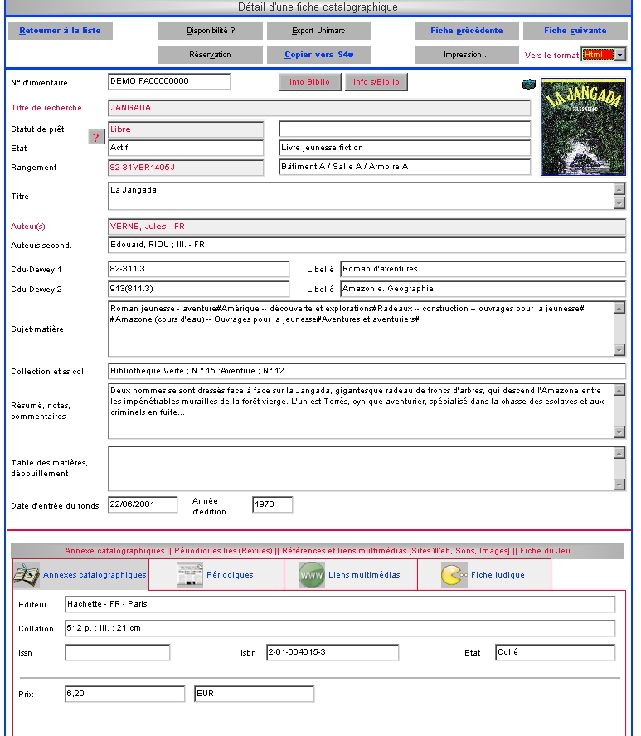
Record details
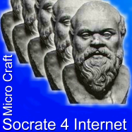
 |  | Because the book  is the memory of man…
www.bibliotheque.be
Microcraft
Bd. Prince de Liège 176
1070 Brussels

S4i@microcraft.be Tel. : +32 (0)19 632 292

Made with the support of

